Marketing Data Analysis Summary

**Process Overview**

The analysis of the XYZ company's marketing dataset followed a structured approach to understand customer behavior, purchasing patterns, and demographic characteristics. The analysis process included data loading, exploration, statistical analysis, and visualization of key variables.

**Data Exploration**

* The dataset contains information on 2,240 customers
* Key variables include demographic information, purchasing behavior, and product preferences
* Eight countries are represented in the dataset: AUS, CA, GER, IND, ME, SA, SP, and US

**Visualizations and Analysis**

1. **Income Distribution Analysis**

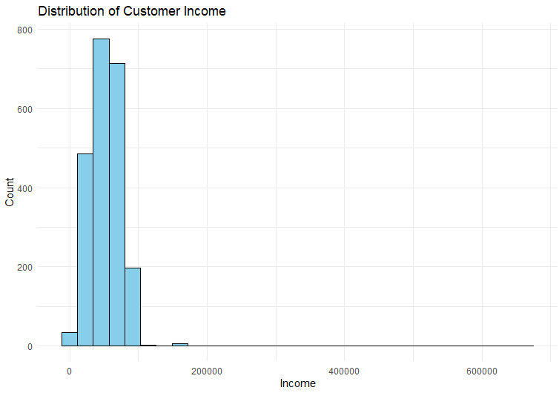

**Key Observations:**

* The histogram reveals a right-skewed income distribution
* Majority of customers cluster in the lower to middle-income ranges (0-200,000)
* Very few customers have incomes above 200,000
* 24 outliers were removed from the visualization
* The distribution suggests a broad middle-class customer base with some high-net-worth clients

**2. Sweet Products Purchase Analysis**

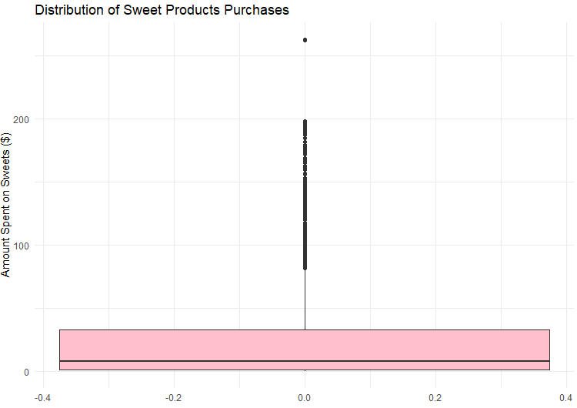**Key Observations:**

* The boxplot shows highly skewed purchase patterns
* Median spending on sweets is relatively low (around $8)
* Multiple outliers indicate some customers with very high sweet product purchases
* The majority of customers maintain modest sweet product spending
* The long whisker and outlier points suggest potential niche market for premium sweet products

**3. Wine Purchases by Country**

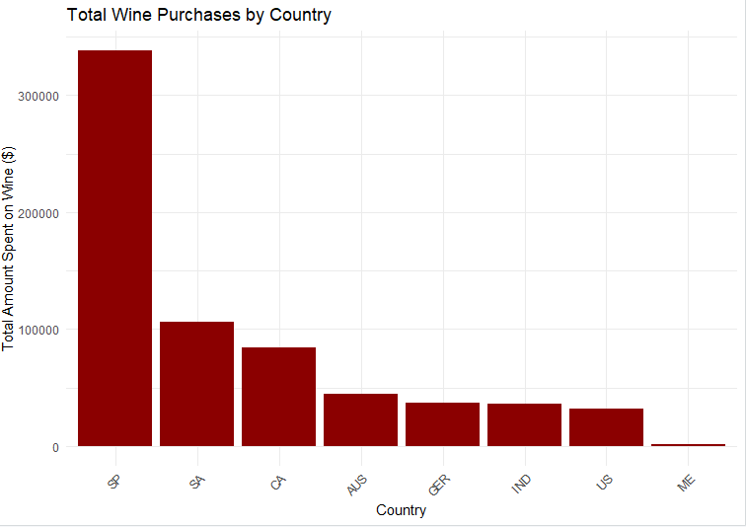**Key Observations:**

* Spain (SP) dominates wine purchases with over $300,000 in total sales
* Clear hierarchical pattern in wine consumption across countries
* South Africa (SA) and Canada (CA) form a second tier of wine markets
* Middle East (ME) shows minimal wine purchases
* The visualization suggests opportunities for market-specific wine promotions

1. Customer Demographics

* Education Levels:
  + Graduation is the most common education level (1,127 customers)
  + PhD (486 customers) and Master's (370 customers) represent a significant portion of the customer base
  + Basic education is the least common (54 customers)

2. Income Distribution

* The income histogram shows a right-skewed distribution
* The majority of customers fall in the lower to middle-income brackets
* There are some notable high-income outliers
* 24 customers had non-finite income values that were removed from the analysis

3. Purchasing Behavior

Wine Purchases by Country

* Spain (SP) shows the highest total wine purchases ($337,991)
* South Africa (SA) and Canada (CA) follow with $105,918 and $84,649 respectively
* Middle East (ME) shows the lowest wine purchases ($1,729)

Store Purchases in the US Market

* Mean store purchases: 6.04 purchases per customer
* Standard deviation: 3.36 purchases
* This indicates moderate variability in store visit frequency

Sweet Products Distribution

* The boxplot shows a highly skewed distribution
* Most customers spend relatively little on sweet products
* There are numerous outliers indicating some high-volume sweet product purchasers

4. Customer Spending Patterns by Education

Average Total Spending by Education Level:

1. PhD: $640 per customer
2. Master's: $571 per customer
3. Graduation: $569 per customer
4. 2nd Cycle: $450 per customer
5. Basic: $59 per customer

This pattern suggests a strong positive correlation between education level and spending behavior.